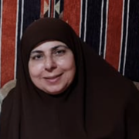

Hoda Elkaim Bio
My name is Hoda Elkaim. I obtained my B.S. degree in Electrical Engineering. I also graduated from Preparation Preachers Institute, Ministry of Endowments. My mother tongue is Arabic. I have Ijazah [Hafs and Shuaba]. I got a Diploma for teaching Tajweed to non-Arabic speakers. I have a certificate for Qaeda Noorania (Noor Al-Bayan). I finished a Tajweed course and an Articulation Course. I work as a Quran teacher in Al-Quran Institute, UK.

